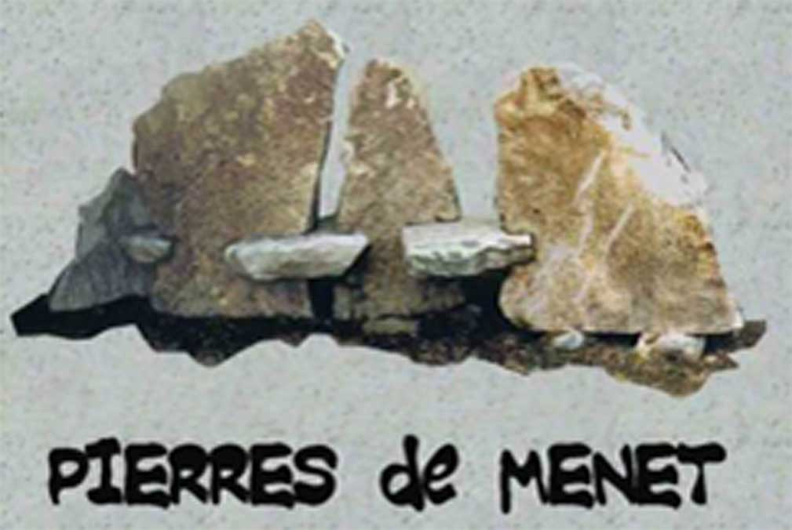 | Association Loi 1901  Mairie 1 rue des Ecoles – 15400 – Menet  France  06 07 78 32 99  e-mail : pierresdemenet@hotmail.com  Internet Site: www.pierresdemenet.com

SYmposium REgulations

32nd International Symposium of Sculpture on Stone

Theme: Perspectives

Presentation

- The International Symposium of Sculpture on Stone organized by the association “Pierres de Menet” takes place in the heart of the Regional Auvergne Volcano Park at Menet, a village with the tourist label “Petite Cité de Caractère” situated in the Cantal .
- It was created in 1992 to enhance the history and heritage of this village founded by stone-cutters who used trachyte, volcanic tuff (or piperno) and phonolite. Specific to this area alone, these types of stone have been traditionally used for centuries for building, roofing and sculpture in the village.

Article 1 : Working conditions - Insurance

- The sculptors work on trachyte extracted from the quarry (density 2.5).
- The sculptors may arrive at the gîte where they will lodge from Sunday July 9 in the afternoon onwards.
- The symposium will start on Monday July 10 at 9 am and finish on July 21 in the evening.
- If they wish to receive the total sum of their indemnity, the artists must be present near their work, so as to be able to describe and present it to the public on the last day, before the tombola is drawn. Their departure will not take place before the morning of July 22.
- For the tombola each artist will execute on the spot or provide free one or two small sculptures (easily transported by hand).
- The association will provide blocks of trachyte of up to approximately 1m³ maximum. The stones, not squared-off, will be cut to approximate size in the quarry according to the dimensions asked for by the sculptors, (density of the stone being approximately 2.6 and composed essentially of feldspar and silica).
- For the first three days, July 10, 11 and 12, the artists will begin work on their sculpture in the quarry.
- This will be the only time when electrical stone-cutting tools may be used.
- The roughly-cut stones will be transferred to the market square in Menet on the morning of July 13.
- The sculptors will then work using traditional manual tools only, in the presence of the public, in the heart of the village of Menet from July 13 until July 21 at 1pm, the afternoon being reserved for the tombola and the presentation of the sculptures to the public for the closing ceremony.
- A minimum number of hours of presence is required : 9am to 12am and 2pm to 6pm.
- The sculptors will answer questions posed by people coming to see them work, thereby adding to public enjoyment of the symposium and knowledge of their art.
- The sculptors must bring their own tools, particularly (diamond) disks and tungsten chisels (steel chisels are not recommended).
- A first-aid kit will be provided for the artists.
- Exhibition premises are provided, but the association’s insurance will not cover work shown; only the symposium is covered by the association.

Article 2 : Food – Lodgings – Travel expenses
- A contribution for travelling costs will be given by the association in total or in part according to the distance and cost of travel. The selected artists will be informed of the sum when they are selected.
- Lodgings are provided by the association, from Sunday July 9 in the afternoon, until Saturday July 22 at 8 am, at which time the gîte will be returned to the owner.
- Morning, noon and evening meals will be provided by the organizers (July 9 in the evening to breakfast July 22). For any special food requirements please notify in advance.
- Personal expenses such as telephone, drinks consumed outside mealtimes etc, will be paid for by the participants.
- Expenses incurred by any persons accompanying the sculptor (lodgings, meals), will not be paid for by the association, which must be informed beforehand in order to find a solution for this possibility

Article 3 : Date and conditions of candidature

- Candidature is free.
- A complete file of application will preferably be sent by e-mail and in PDF to: pierresdemenet@hotmail.com, but an application may also be sent to the association by post at the following address : Mairie de Menet, 1 rue des Écoles, 15400-MENET, FRANCE,
BEFORE MARCH 1 2023 : RESULTS WILL BE KNOWN ON APRIL 15 2023.

Article 4 : Composition of the application file

- The application file will be made up of ;
  - the accompanying regulations dated and signed, constituting an engagement of participation in the symposium over the complete period in case of selection,
  - the candidate's CV (resume) with contact details, including a telephone number and an e-mail address,
  - sketches and/or photo(s) WITH DIMENSION(S) of the project,
  - a short text explaining the artistic approach to the original work in relation to the theme of the symposium,
  - a few photos, press cuttings, references etc. representative of the sculptor's work in stone.

Article 5 : Selection of the candidates

- The selected sculptors will be informed by e-mail or text message from April 15 2023 onwards.
- The list of selected sculptors will also be shown on the Internet site : pierresdemenet.com

Article 6 : Payment

- Each sculptor will receive a total sum of 1500€ (one thousand, five hundred Euros) at the end of the symposium for his/her sculpture, plus an indemnity for travelling expenses (cf. article 2).

Article 7 : Ownership rights

- The work will remain the property of the association Pierres de Menet, and the sculptor will grant the association the right to use images of his work executed during the symposium and the right to sell.

Article 8 : Sharing

- During the period of the symposium, the 21st European Encounters will take place : 50 young people will work on an identical but slightly more precise theme “Perspectives (Rhythms, Freedom, Sharing), allowing the possibility of exchanging with the young people on a voluntary basis.

SURNAME/FAMILY NAME : ....................................First name/Forename :

Date:

Signature preceded by “Read and approved”

